|  |  |  |  |
| --- | --- | --- | --- |
| 1 | | 3,000 | |
| **NUMERO DE FRONTERAS** | | **ENERGIA AGREGADA** | |
|  | | | |
| 5,900,151 | 71 | | 230,244 |
| INGRESO 2019 | DÍAS CERTIFICADOS 2019 | | ENERGIA RESPALDADA 2019 |
|  | | | |
| 19,003,262 | 76 | | 755,122 |
| INGRESO 2020 | DÍAS CERTIFICADOS 2020 | | ENERGIA RESPALDADA 2020 |
|  | | | |
| 200,924 | 3 | | 9,000 |
| INGRESO 2021 | DÍAS CERTIFICADOS 2021 | | ENERGIA RESPALDADA 2021 |

**HISTORICO REINTEGRO DDV**

|  |  |  |  |
| --- | --- | --- | --- |
|  | **2019** | **2020** | **2021** |
| **ENE** | - | - | 0.2 |
| **FEB** | 1.06 | - | - |
| **MAR** | 0.07 | - | - |
| **ABR** | 0.34 | - | - |
| **MAY** | 1.84 | 1.07 | - |
| **JUN** | 0.86 | 4.13 | - |
| **JUL** | 0.61 | 6.83 | - |
| **AGO** | - | 6.28 | - |
| **SEP** | 0.72 | - | - |
| **OCT** | 0.4 | 0.43 | - |
| **NOV** | - | - | - |
| **DIC** | - | 0.26 | - |

**Los valores de la tabla están en millones de COP**



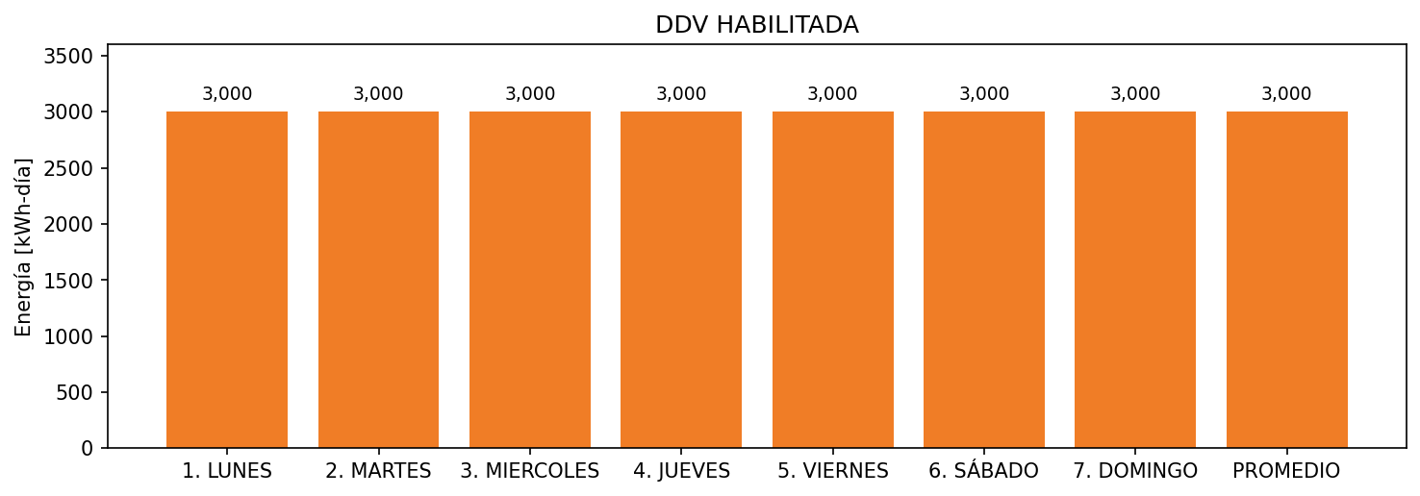

|  |  |  |  |  |  |  |  |  |  |
| --- | --- | --- | --- | --- | --- | --- | --- | --- | --- |
| **FRONTERA** | **COD SIC** | **FRT DDV** | **TIPO DDV** | **PROMEDIO** | **PRÓXIMA ACTUALIZACIÓN** | **MARGEN DE ERROR** | **ÚLTIMA PRUEBA DDV** | **DÍAS PARTICIPACIÓN** | **FECHA REFERENCIA PRÓXIMA PRUEBA DDV** |
| HOTEL HAMPTON BARRANQUILLA | Frt20145 | Frt37987 | GPE | 3,000 | 2023-04-15 | NO APLICA | 2020-05-08 | 79.0 | 2021-12-18 |